Nitish Panda
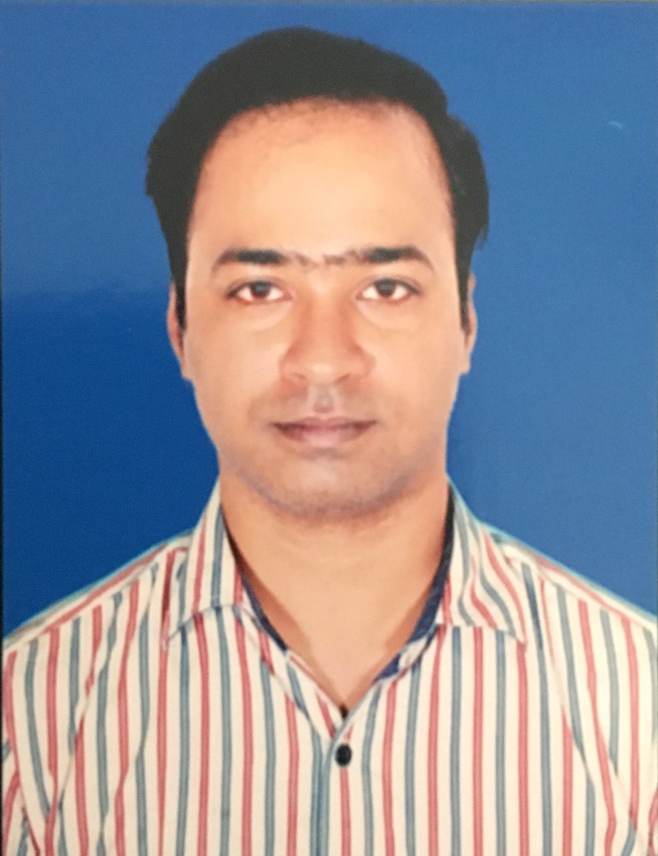
Plot No – A/416, Kalpana River View Apartment
Bankual, Bhubaneswar
e-mail: nitishpanda101@gmail.com
Contact No: 09937929198

Ambitious and enthusiastic professional achieving consistent results and developing strong working relationship with clients and internal team players.

Career Abstract

- Professional with over 10 Years of experience in Customer Service, Operations, Marketing, Client Relationship Management, Corporate sales and Team Management.
- Flair for accepting challenges with entrepreneurship abilities in managing & leading overall functions and achieving desired targets.
- Understanding target audience and work towards segment identified; Building valid Data Bases to help execution of targeted marketing campaigns.
- Build/ Improve brand awareness, engagement and demand generation by leveraging marketing channels and agencies effectively.
- Expertise in identifying key accounts, managing portfolio, expanding client base for augmenting turnovers and achieving desired targets / goals.
- Conversant with the concepts & processes of Customer Delivery, Marketing and back end processes.
- Managing teams to work in sync with the corporate set parameters & motivating them for achieving business and individual goals.
- Effective communicator with excellent relationship building & interpersonal skills. Strong analytical, problem solving & organisational abilities.

Core Competencies:-
- Imaginative and innovative individual with proven Management, Corporate Sales, Advertising, Marketing, Customer Service and New business development skills.
- Ability for setting new market & developed the Client base from the target sector.
- Building and maintaining healthy business relations with clients, ensuring maximum customer satisfaction by achieving delivery & quality norms.
- Areas of Excellence include:

Strategic Planning Key Account Management Sales & Marketing Customer Relationship Management Business Development Product Promotion
Communication Skills

Employment Record

- Presently working as a Sr. Executive-Marketing from 2nd Sep 2013 to till Date with Jyote Group.- An Automobile Dealership Company for reputed automobile Companies like MSIL, TVS, AUDI, SUZUKI, HARLEY DEVIDSON,NEXA.
Key Results Area:-
- Determining marketing objectives.
- Experienced in planning marketing campaigns, getting collaterals developed and promoting the products and services through online and print media.
- Monitoring day to day activities with Enquiry generation and enquiry conversion.
- Day to Day Coordination with local/out of state vendors for Branding Materials.
- Experienced in forging and maintaining relationship with online, print and television media & Ad Agencies.
- Maintaining relationship with Corporates like Infosys, TCS, Wipro, IBM.
- Organizing Activities with SME’s & Minor Corporate Clients of Orissa.
- Planning marketing activities in conjunction with company’s growth plan and working out strategies to execute the plan as per the budget.
- Design, planning, execution and monitoring of all marketing programs (online and offline) to meet product awareness goals and development of pipeline for the sales team.

- As a Business Development Manager with M/s Cosmoquest Infocreations from December 2009 – August 2013.

Key Results Area:-
- Dealing with clients and analyze their requirements to provide business solutions.
- To bring more business to the organization which included adding more and more new clients along with providing services to the existing customers.
- To guide the new associates joining the organization and helping them out to contribute towards the organization operations.
Major Achievements:

Added clients like ARSS, METRO Builders, DARSHAN group of Companies, KAR VISION EYE HOSPITAL etc. in limited time and provided end to end customer satisfaction.

Academic and Professional Qualification:
- MBA (Marketing and HR) in Center for Management Studies (CMS) under Biju Patnaik University of Technology (BPUT) in 2007-2009.
- B.A from Autonomous college, Bhawanipatna under Sambalpur University in 2004-07.
- +2 Arts from Junior government college, Bhabanipatna under CHSE, Orissa.
- 10th passed from Saraswati vidya mandir ,Khariar under BSE,Orissa.

Technical Summary:-
- Diploma in Computer Application (D.C.A)
- Tally 7.2

Academic Project
Company: Bajaj Automobiles
Title: Product Positioning

Personal Vitae
Name: Nitish Panda
Father’s name: Mr. Sarada Prasad Panda
Date of birth: 4th Feb. 1987
Address: A/416,Kalpana River View Apartment , Bankual, Bhubaneswar,751002
Sex: Male
Marital status: Married
Religion: Hindu
Nationality: Indian
Languages known: English, Oriya, Hindi

DECLARATION: .

I do hereby declare that the information’s given in the resume are true to the best of my knowledge.

Date:
Place: Bhubaneswar Nitish Panda

